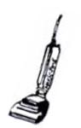
A Gift of Maid Service Certificate #125
For You

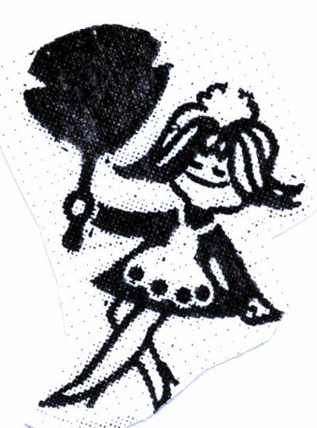

FOR
FROM MESSAGE
DATE
Marie Page Cleaning Services,LLC
P.O. Box 324 Reeder's Run Road
Reeders, Pa. 18352.
www.mariepageservices.com
570-629-7811
Authorized by___________________________________
This certificate entitles you to Service with A Maid
based on amount purchased.
This is a basic list for your convenience
You are required to have all cleaning supplies and vacuum

- Dusting /Polishing furniture
- Windexing of glass fixtures
- Dust all wall hangings
- Clean and sanitize bathrooms
- Clean and sanitize kitchens
- Dust ceiling fans
- Dust blinds
- Wood Flooring-(cleaned as per customer request only)
- Vacuuming- upholstered furniture / carpeting
- Sweep and wash all bare flooring

Gift Certificate # 125
Return this signed portion of certificate with your maid:

Certificate Holder Signature: _____________________________________

Date Service Performed: _____________________

TIME ARRIVED:_____________ EMPLOYEE:__________________________

TIME FINISHED:_____________ EMPLOYEE:__________________________

WE HOPE WE HAVE “MAID” YOUR LIFE A LITTLE EASIER

